Thermometer Charts

A thermometer Chart is a variation of a bar chart.

Use the data available in the excel. Where value represents the percentage

0.9 means 90%,0.5 means 50%,0.7 means 70% and 0.3 means 30%.

The Path is for Data Densification.

Copy paste the data sets to the data source clipboard and create a cross join using edit connection and type 1 for both data sets.

Create a bin for the path measure

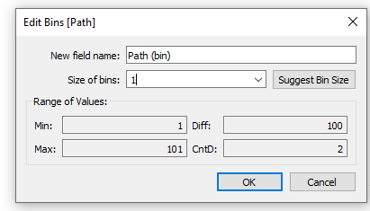

Create a calculated field index

INDEX()-1

As we want to start at 0% as opposed to 1

Index always returns 1 and its position within the configuration.

Drag country to the columns field and index and path(bin) to the rows shelf.

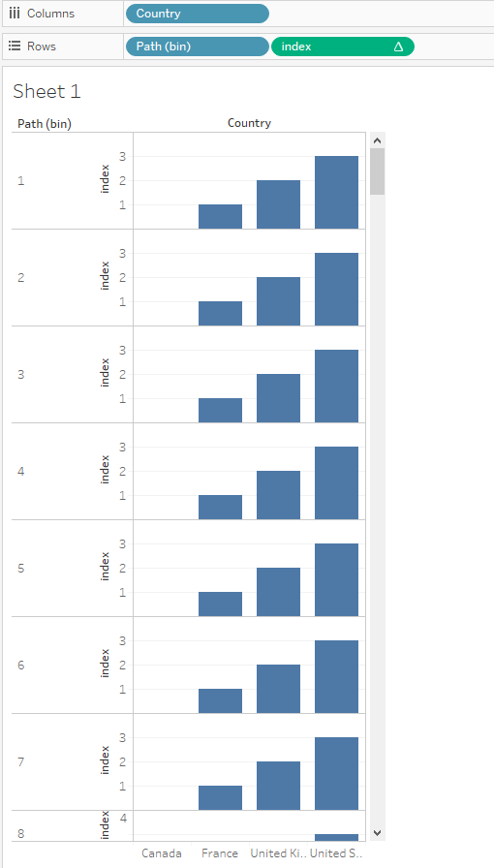

Click on path(bin) and make sure the missing values is enabled.

Change the mark type to line.

Drag path(bin) to the path shelf in the marks card.

Click on index in the rows shelf and compute using path(bin).

The result will act as a container.

Create a calculated field TC_value

WINDOW_MAX(MAX([Value]))

Create another calculated Value

TC_thermometer_value

[index]*[TC_value]

Drag the TC_thermometer_value to the right of index in the rows field and compute using path(bin).

Now we have o to 100 % and for each country we have the value.

Create another calculated field for the size of the container

TC_size(container)

IF [index]=0 THEN 1

ELSE 0

END

Duplicate the TC_size(container) and rename it to TC_size(thermometer).

Click on index on the marks card and click on the color and change it to grey.

Drag the TC_size container to the size in marks card and then edit sizes.

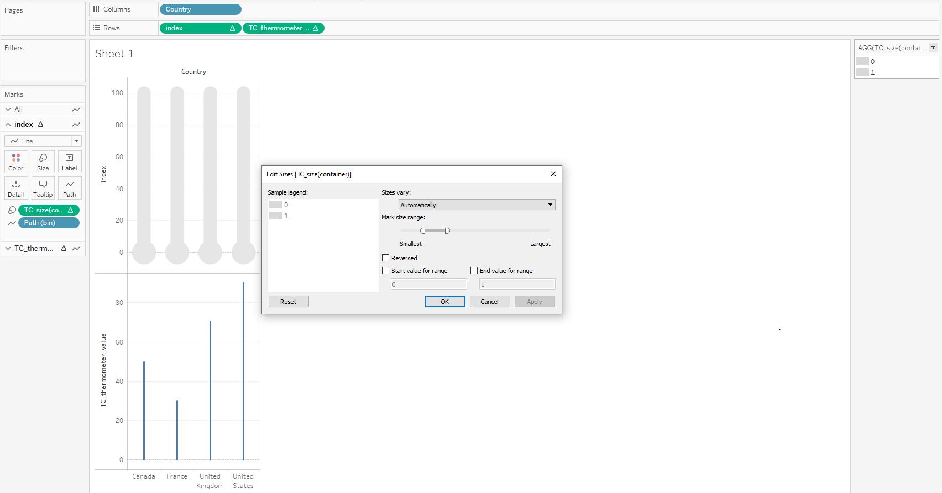

Click on TC_thermometer on the marks card and drag TC_size(thermometer) to the size shelf and edit the size.

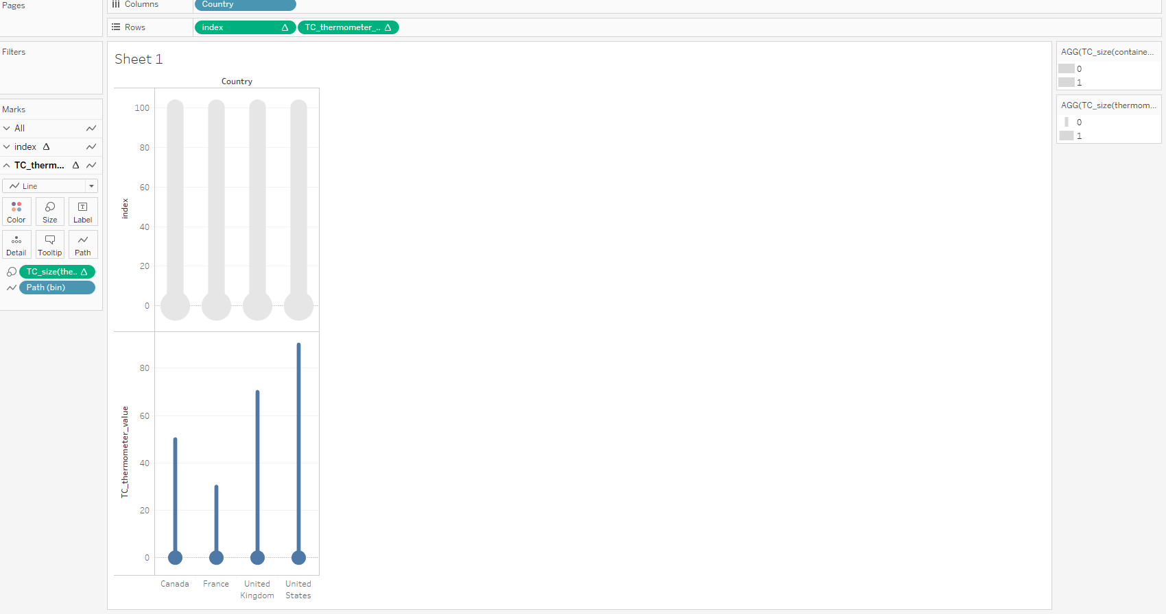

Click on TC_thermometer on the rows shelf and clik on dual axis and synchronize axis.

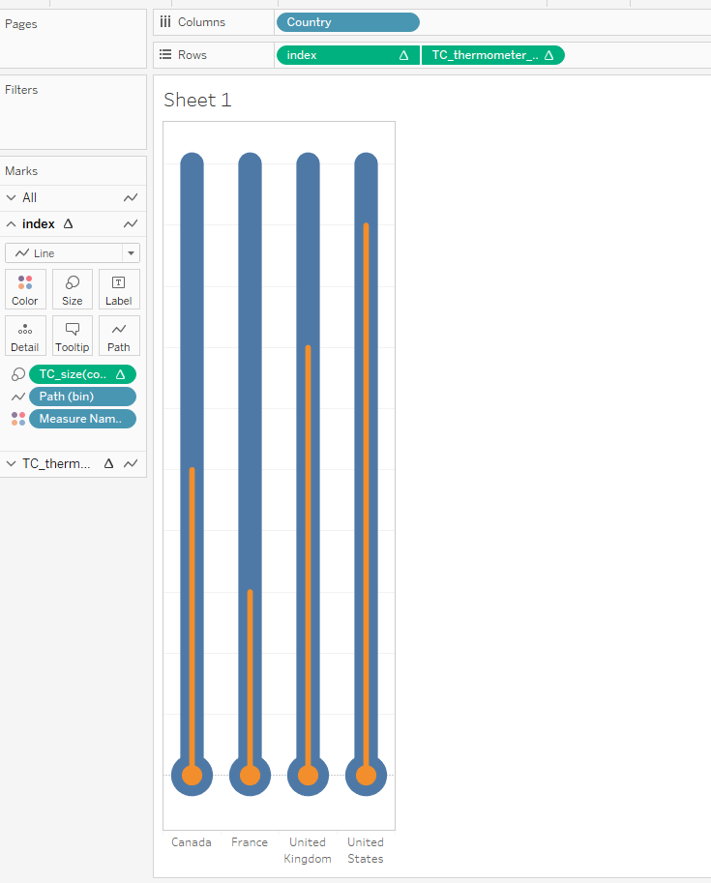

Click on TC_thermometer on the marks card and drag values on the label shelf and format as desired.

Click on the sum value on the labels shelf and format and change the number type to percentage.

Click on All on the marks card and disable the tool tip.

The final work sheet looks like this.

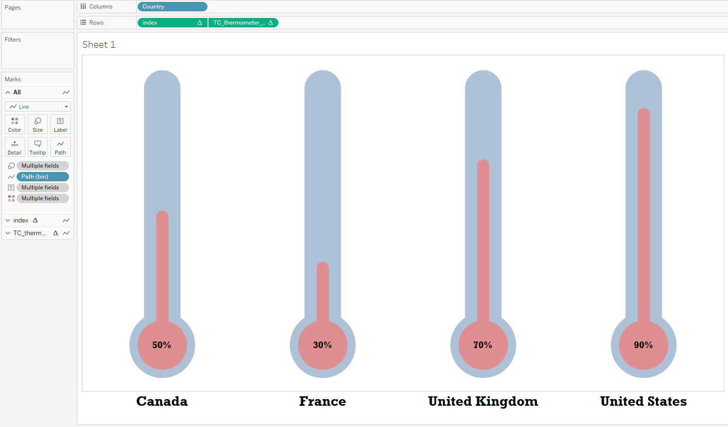

Final Touch

Click on TC_thermometer on the marks shelf and drag TC_thermometer value to the colors shelf and compute using path(bin) which gives smooth gradient.

